Net 1061 Switching, Routing, and Wireless Essentials

Name:

Lab: #

Follow the instructions down below for the lab itself. For this lab, all answers need to be in blue font. For the questions right below, answer in complete sentences. If this is a self-grading packet tracer. Ensure you paste the screen shot of your score page at the bottom of the document. You will upload both this document and the pkt file regardless if it is self-grading or not. Let the instructor know if you have any questions.

Lab Analysis Report

1. Using complete sentences summarize work you completed during the lab.
In this lab, first I configured the VLANs and assigned the ports to them. Then, I configured the trunking ports on all three switches. Finally, I verified connectivity between all the devices.

2. Using complete sentences describe what you learned from the lab. Hint; look at the lab objectives listed at the top of the lab section.
In this lab, I learned more about how the different trunk modes work. I also learned how mismatching native VLANs can cause connectivity issues.

Problems Encountered

1. Using complete sentences describe any problem(s) experienced during lab.
I didn’t experience any problems.

2. Using complete sentences describe how you solved your problem(s).

3. Using complete sentences explain if you needed any assistance with the lab; then list what you learned from that assistance.

Packet Tracer - Configure DTP

Addressing Table
Device | Interface | IP Address | Subnet Mask
PC1 | NIC | 192.168.10.1 | 255.255.255.0
PC2 | NIC | 192.168.20.1 | 255.255.255.0
PC3 | NIC | 192.168.30.1 | 255.255.255.0
PC4 | NIC | 192.168.30.2 | 255.255.255.0
PC5 | NIC | 192.168.20.2 | 255.255.255.0
PC6 | NIC | 192.168.10.2 | 255.255.255.0
S1 | VLAN 99 | 192.168.99.1 | 255.255.255.0
S2 | VLAN 99 | 192.168.99.2 | 255.255.255.0
S3 | VLAN 99 | 192.168.99.3 | 255.255.255.0

Objectives
- Configure static trunking
- Configure and Verify DTP

Background / Scenario
As the number of switches in a network increases, the administration necessary to manage the VLANs and trunks can be challenging. To ease some of the VLAN and trunking configurations, trunk negotiation between network devices is managed by the Dynamic Trunking Protocol (DTP), and is automatically enabled on Catalyst 2960 and Catalyst 3650 switches.
In this activity, you will configure trunk links between the switches. You will assign ports to VLANs and verify end-to-end connectivity between hosts in the same VLAN. You will configure trunk links between the switches, and you will configure VLAN 999 as the native VLAN.

Instructions

Verify VLAN configuration.
Verify the configured VLANs on the switches.
    - On S1, go to privileged EXEC mode and enter the show vlan brief command to verify the VLANs that are present.
Open configuration window
S1# show vlan brief

VLAN Name Status Ports
---- -------------------------------- --------- -------------------------------
1 default active Fa0/1, Fa0/2, Fa0/3, Fa0/4
Fa0/5, Fa0/6, Fa0/7, Fa0/8
Fa0/9, Fa0/10, Fa0/11, Fa0/12
Fa0/13, Fa0/14, Fa0/15, Fa0/16
Fa0/17, Fa0/18, Fa0/19, Fa0/20
Fa0/21, Fa0/22, Fa0/23, Fa0/24
Gig0/1, Gig0/2
99 Management active
999 Native active
1002 fddi-default active
1003 token-ring-default active
1004 fddinet-default active
1005 trnet-default active
    - Repeat Step 1a on S2 and S3.

Question:
What VLANs are configured on the switches?
VLAN 1, VLAN 99, and VLAN 999 are configured.Type your answers here.

Create additional VLANs on S2 and S3.
    - On S2, create VLAN 10 and name it Red.
S2(config)# vlan 10
S2(config-vlan)# name Red
    - Create VLANs 20 and 30 according to the table below.
VLAN Number | VLAN Name
10 | Red
20 | Blue
30 | Yellow
    - Verify the addition of the new VLANs. Enter show vlan brief at the privileged EXEC mode.

Question:
In addition to the default VLANs, which VLANs are configured on S2?
VLAN 10, 20, 30, 99, and 999 are all configured.your answers here.
    - Repeat the previous steps to create the additional VLANs on S3.

Assign VLANs to Ports
Use the switchport mode access command to set access mode for the access links. Use the switchport access vlan vlan-id command to assign a VLAN to an access port.
Ports | Assignments | Network
S2 F0/1 – 8  S3 F0/1 – 8 | VLAN 10 (Red) | 192.168.10.0 /24
S2 F0/9 – 16  S3 F0/9 – 16 | VLAN 20 (Blue) | 192.168.20.0 /24
S2 F0/17 – 24  S3 F0/17 – 24 | VLAN 30 (Yellow) | 192.168.30.0 /24
    - Assign VLANs to ports on S2 using assignments from the table above.
S2(config-if)# interface range f0/1 - 8
S2(config-if-range)# switchport mode access
S2(config-if-range)# switchport access vlan 10
S2(config-if-range)# interface range f0/9 -16
S2(config-if-range)# switchport mode access
S2(config-if-range)# switchport access vlan 20
S2(config-if-range)# interface range f0/17 - 24
S2(config-if-range)# switchport mode access
S2(config-if-range)# switchport access vlan 30
    - Assign VLANs to ports on S3 using the assignments from the table above.
Now that you have the ports assigned to VLANs, try to ping from PC1 to PC6.

Question:
Was the ping successful? Explain.
No, there isn’t a router to send data to the PC on another switch.Type your answers here.

Configure Trunks on S1, S2, and S3.
Dynamic trunking protocol (DTP) manages the trunk links between Cisco switches. Currently, all the switchports are in the default trunking mode, which is dynamic auto. In this step, you will change the trunking mode to dynamic desirable for the link between switches S1 and S2. The link between switches S1 and S3 will be set as a static trunk. Use VLAN 999 as the native VLAN in this topology.
    - On switch S1, configure the trunk link to dynamic desirable on the GigabitEthernet 0/1 interface. The configuration of S1 is shown below.
S1(config)# interface g0/1
S1(config-if)# switchport mode dynamic desirable

Question:
What will be the result of trunk negotiation between S1 and S2?
They will send trunk data to each other if initiated.Type your answers here.
    - On switch S2, verify that the trunk has been negotiated by entering the show interfaces trunk command. Interface GigabitEthernet 0/1 should appear in the output.

Question:
What is the mode and status for this port?
The mode is auto and the status is trunking.your answers here.
    - For the trunk link between S1 and S3, configure interface GigabitEthernet 0/2 as a static trunk link on S1. In addition, disable DTP negotiation on interface G0/2 on S1.
S1(config)# interface g0/2
S1(config-if)# switchport mode trunk
S1(config-if)# switchport nonegotiate
    - Use the show dtp command to verify the status of DTP.
S1# show dtp
Global DTP information
Sending DTP Hello packets every 30 seconds
Dynamic Trunk timeout is 300 seconds
1 interfaces using DTP
    - Verify trunking is enabled on all the switches using the show interfaces trunk command.
S1# show interfaces trunk
Port Mode Encapsulation Status Native vlan
Gig0/1 desirable n-802.1q trunking 1
Gig0/2 on 802.1q trunking 1

Port Vlans allowed on trunk
Gig0/1 1-1005
Gig0/2 1-1005

Port Vlans allowed and active in management domain
Gig0/1 1,99,999
Gig0/2 1,99,999

Port Vlans in spanning tree forwarding state and not pruned
Gig0/1 1,99,999
Gig0/2 1,99,999

Question:
What is the native VLAN for these trunks currently?
The native VLAN is 1.Type your answers here.
    - Configure VLAN 999 as the native VLAN for the trunk links on S1.
S1(config)# interface range g0/1 - 2
S1(config-if-range)# switchport trunk native vlan 999

Question:
What messages did you receive on S1? How would you correct it?
Inconsistent VLAN. VLAN mismatched. Change the native VLAN on s2 and s3s trunk port.Type your answers here.
    - On S2 and S3, configure VLAN 999 as the native VLAN.
    - Verify trunking is successfully configured on all the switches. You should be able ping one switch from another switch in the topology using the IP addresses configured on the SVI.
    - Attempt to ping from PC1 to PC6.

Question:
Why was the ping unsuccessful? (Hint: Look at the ‘show vlan brief’ output from all three switches. Compare the outputs from the ‘show interface trunk’ on all switches.)
The VLANs aren’t configured on S1.your answers here.
    - Correct the configuration as necessary.

Reconfigure trunk on S3.
    - Issue the ‘show interface trunk’ command on S3.

Question:
What is the mode and encapsulation on G0/2?
The mode is on and the encapsulation is 802.1q.your answers here.
    - Configure G0/2 to match G0/2 on S1.

Question:
What is the mode and encapsulation on G0/2 after the change?
The mode is on and the encapsulation is 802.1q.Type your answers here.
    - Issue the command ‘show interface G0/2 switchport’ on switch S3.

Question:
What is the ‘Negotiation of Trunking’ state displayed?
It’s set to off.Type your answers here.
Close configuration window

Verify end to end connectivity.
    - From PC1 ping PC6.
    - From PC2 ping PC5.
    - From PC3 ping PC4.
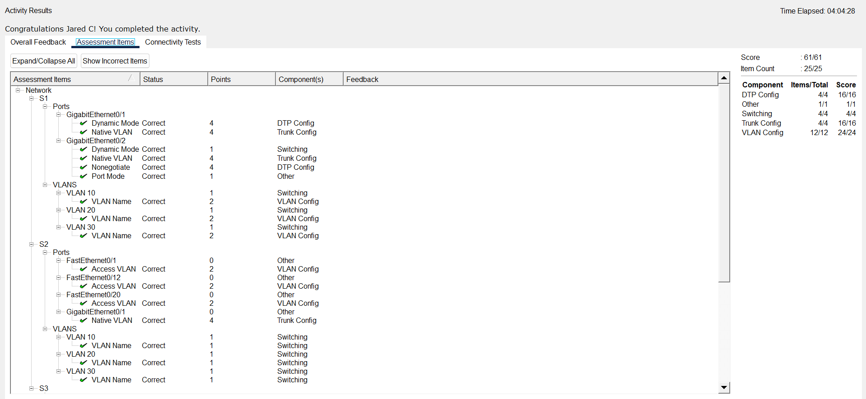
End of document

